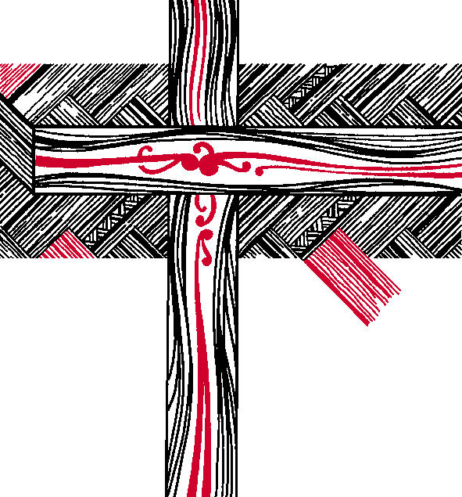 | The Anglican Church in Aotearoa,  New Zealand and Polynesia  Te Hāhi Mihinare ki Aotearoa ki Niu Tireni, ki Ngā Moutere o te Moana Nui a Kiwa

JUDICIAL COMMITTEE

Minutes of a Meeting held by email on Monday 12 February 2018

Present
House of Bishops | The Rt Rev’d Victoria Matthews
House of Clergy  Tikanga Māori | The Rev’d Joel Rowse  Judge Stephanie Milroy  Mr David Stone
Tikanga Pākehā | Judge Chris Harding  Judge Anne McAloon  Ms Brigit Brant
Tikanga Pasefika | Mr Walton Morgan  Ms Mele Taliai
General Secretary | Rev’d Michael Hughes

________________________________________________________________________

- POSSIBLE STANDING RESOLUTIONS FROM GSTHW 2016
The General Secretary advised the Committee that he had reviewed the GSTHW 2016 resolutions, and that none requested consideration as a Standing Resolution, and he did not see any that clearly appeared to require such designation to remain in force as Standing Resolutions.

The full set of resolutions were circulated to the Committee, seeking their agreement.

- STANDING ORDER DRAFTING
The Judicial Committee was asked to draft a standing order in relation to social media, but considered that the Synod may have confused standing orders with standing resolutions and that changing standing orders is within the power of Synod generally, subject to the provisions of Standing Order 104 regarding notice and a Committee process within synod for that to happen.

Resolved: The Committee on Statutes and Canons would ordinarily be the appropriate body to draft an amendment to a Standing Order and to offer it to the Synod/te Hīnota and they should be invited to do that. This committee is not the proper body to do that

By email reply the Committee agreed that no 2016 resolutions required to remain in force.

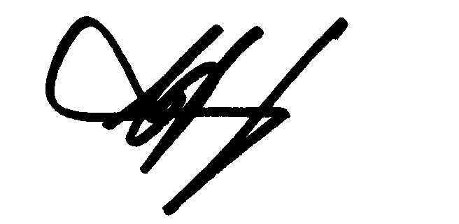
11 March 2018
_________________________________ ______________________
CJ Harding, Chair Date

